PARTE 3

**1.** be careful! A. yes, ido

B. I will

C. what a pity!

2. who's that girls A. yes, she is

B. that's right

C. my sister

3. what do you think of the teacher? A. great school!

B. I think so

C. I love his class

4. do you know martha? A. who?

B. which?

C. how?

5. can you pass me the salt? A. here you are

B. I like it

C. it's all right

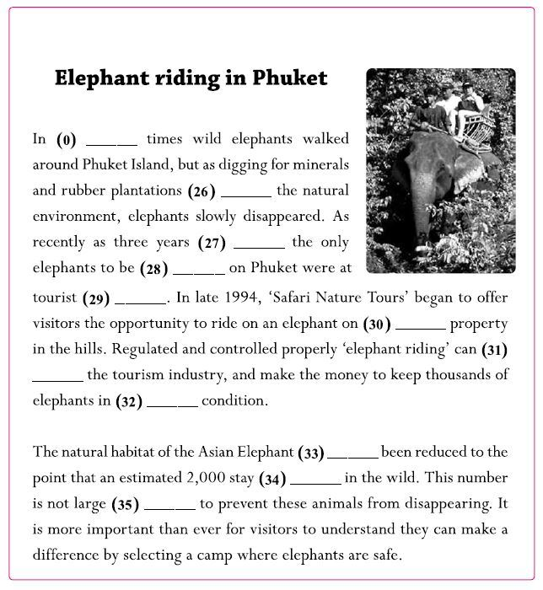Prueba Parte 4

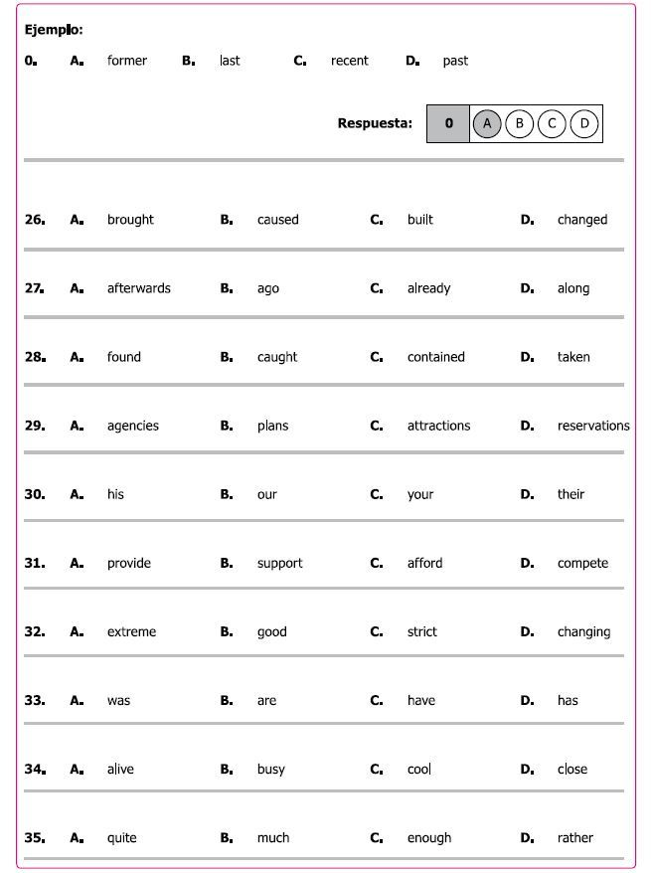

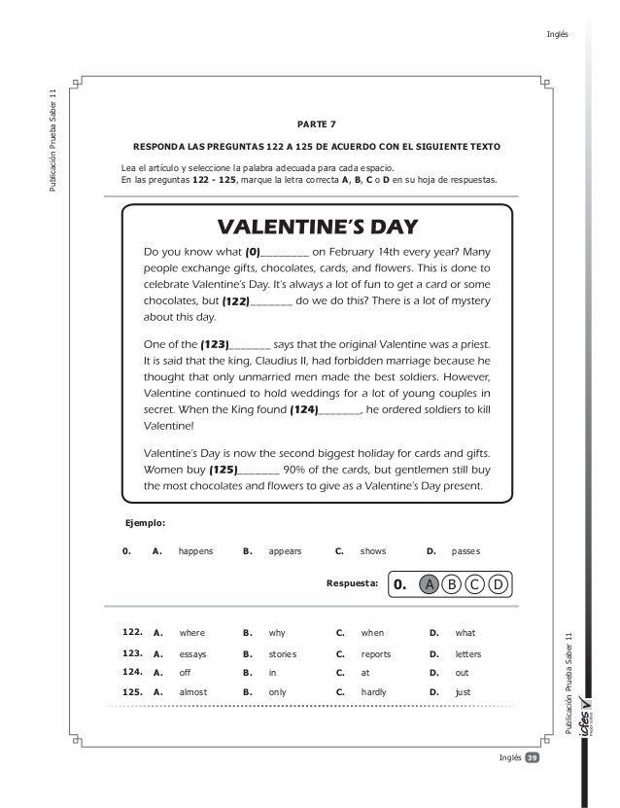

Alumno: Milton Puentes

Grado: 1101 JM