PARTE 3

**1 .**  do you have my pink pen ? A. come on

B.yes, it’s on the table

C. you are good?

2. you are going to the party on Saturday? A. I'm hungry

B. I am fine , how are you?

C. of course

3. you want to go to eat? A. of course I spend

B. table

C. it´s my computer

4. Can yo lend me your cell phone? A. is loading

B. the weekend

C. in the pool

5. lets go to the cinema? A. what movie are we going to watch?

B. Yes, she is

C. my dad

RESPONDE: MILTON PUENTES 1101 JM

RESPUESTAS

1 A

B

C

2 A

B

C

3 A

B

C

4 A

B

C

5 A

B

C

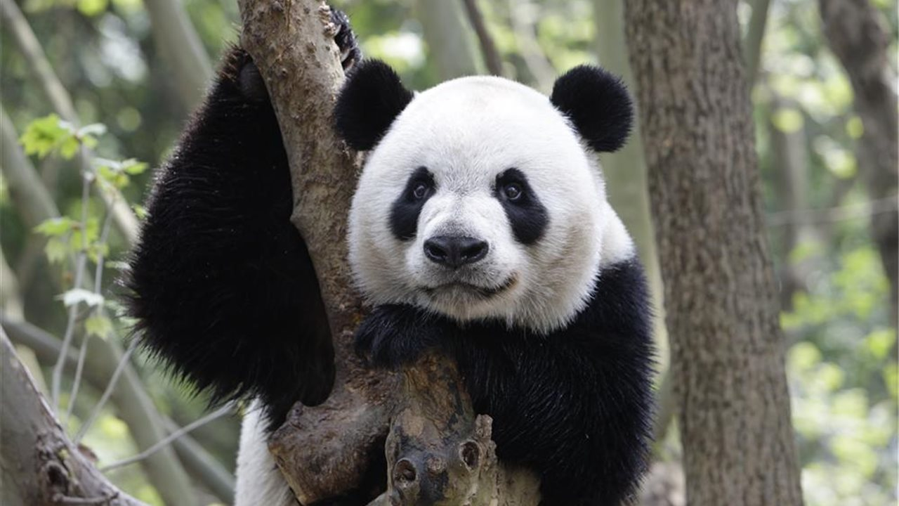

The appetite of this mammal is insatiable and can spend more than half the day eating what it likes most without rest: bamboo Despite its slow and clumsy appearance, it is a very agile animal climbing trees as well as swimming through the water. They usually have a behavior sociable except when they seek to mate. Females go through a gestation period of 5 months Until the baby is born, totally blind and white.

They usually live between fifteen and twenty years, weigh about 130 kilos and can reach 1.5 meters. Its natural habitat is the mountainous areas of

China

1. A. milk B. bamboo C.insects
2. A. mountains B. ropes C.trees
3. A. lonely B. friendly C.sociable
4. A. 5 months B. 9 months C. 3 months
5. A. China B. Canada C.Colombia

Responde: MILTON PUENTES 1101 JM